1. **New Homepage A/B Test Analysis**

By Alina Barsan

08/05/2023

1. **Summary**

I recommend that we should launch the new homepage because we observed strong evidence that there was an increase in revenue per user.

1. **Context**

We ran an A/B test with a new design for the homepage, which was adding a banner that highlights key products in the food and drink category at the top of the website, to see if it would increase revenue.

The control group does not see the banner, and the treatment group sees it as shown below:



The setup for the A/B test was as follows: the experiment was only run on the mobile website; a user visits the GloBox main page and is randomly assigned to either the control or test group, this is the join date for the user; the page loads the banner if the user is assigned to the test group, and does not load the banner if the user is assigned to the control group; the user subsequently may or may not purchase products from the website. It could be on the same day they join the experiment, or days later. If they do make one or more purchases, this is considered a “conversion”.

The experiment ran for 12 days (23.01.2023 - 06.02.2023).

There were 24343 users in the control group and 24600 users in the treatment group.

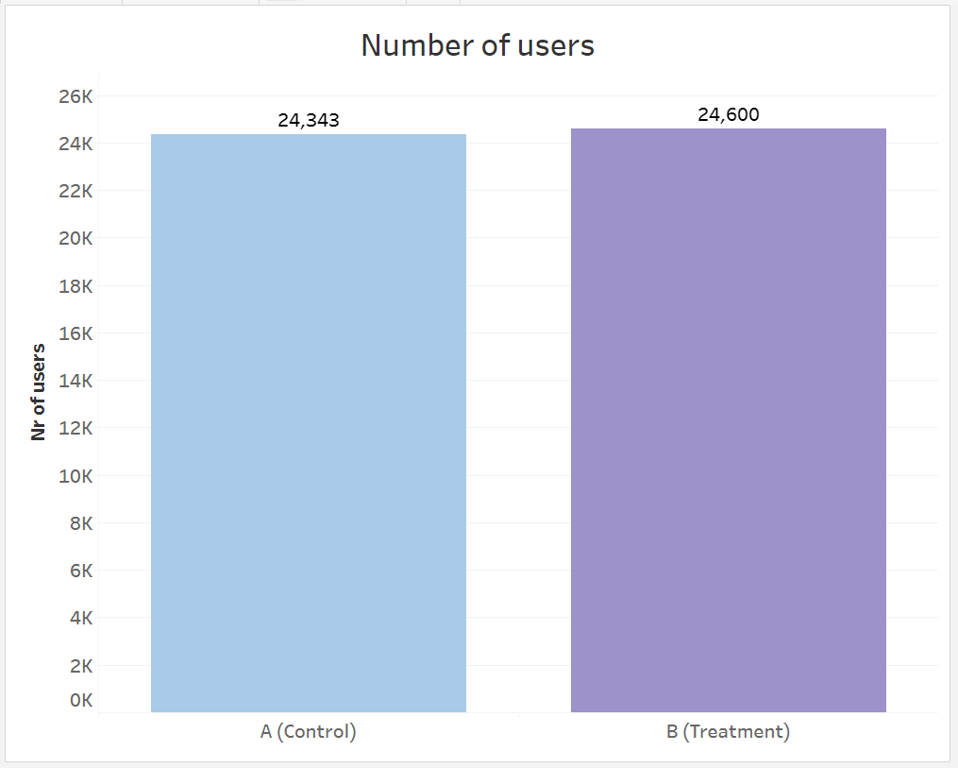

1. **Results**

In order to determine if there was a difference in revenue per user between the two groups, we ran a hypothesis test. We saw a statistically significant difference between the control group and the treatment group, at the 5% significance level, the p-value = 0.0001, we reject the null hypothesis that there is no difference in the user conversion rate between the control and treatment.

The 95% confidence interval for the difference in the conversion rate between the treatment group and the control group is (0.0035, 0.0107).

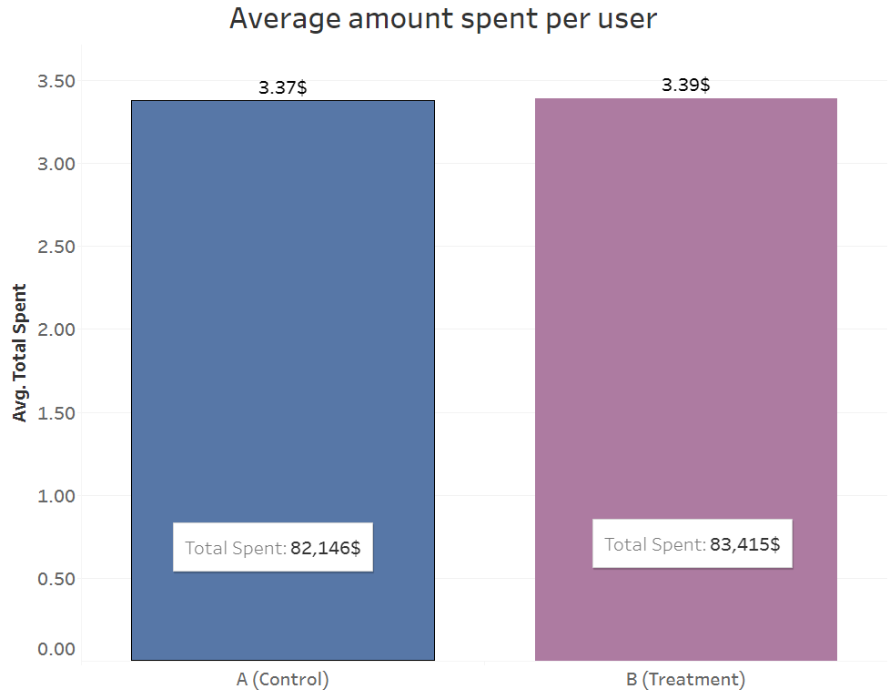

1. **Recommandation**

We recommend launching the new homepage, there is strong evidence for increased revenue, the treatment group had higher average revenue.

1. **Appendix**

**SQL - codes -**

**Average spent per user**

WITH total_spent AS (

SELECT SUM(spent) as total,

a.uid

FROM activity a

GROUP BY a.uid

)

SELECT AVG(COALESCE(total,0)) as avg_spent,

g.group

FROM users

JOIN groups g

ON users.id = g.uid

LEFT JOIN total_spent ts

ON ts.uid = users.id

GROUP BY g.group

**Standard deviation and xbar**

WITH total_spent AS (

SELECT SUM(spent) as total,

a.uid

FROM activity a

GROUP BY a.uid

)

SELECT AVG(COALESCE(total,0)) as avg_spent, STDDEV(COALESCE(total,0)) as std,

g.group

FROM users

JOIN groups g

ON users.id = g.uid

LEFT JOIN total_spent ts

ON ts.uid = users.id

GROUP BY g.group

**Total spent for groups A and B**

WITH cte AS (

SELECT uid, "group", SUM(spent) AS total_spent

FROM groups

left join activity

using(uid)

GROUP BY uid,"group"

), cte_2 as

(select uid, "group", (COALESCE(total_spent, 0)) total_spent from cte)

select * from cte_2

**Spreadsheets link**

<https://docs.google.com/spreadsheets/d/1j9vY0cwODz3W73tTh5W6fEBRZVn11lLoXrwp7HGc4k4/edit?usp=sharing>

**Tableau link**

<https://public.tableau.com/views/ABtest_16832849281720/Nrofusers?:language=en-US&:display_count=n&:origin=viz_share_link>